**KENYA SCHOOL OF LAW**



**ADVOCATES TRAINING PROGRAMME**

**ATP 107- CONVEYANCING**

**CLASS E**

**FIRM 7 PRESENTATION**

**TASK**

**Completion documents for sale agreements drafted by Firm 3 and 5 (excluding the transfer)**

Contents

**INTRODUCTION** 2

**FIRM 3 (Sale agreement for a Flat in New Development)** 3

(i) Original registered lease document in respect to flat Number 11A in Block A duly-executed by the vendor the Management Company and the Purchaser herein. 3

(ii) Certified copy of the Head title 4

(iii) Certified copies of Memorandum and articles of association of super height Point Properties Limited Duly-registered at the Attorney General`s Chambers. 6

(iv) The original KRA receipt showing payment of stamp duty. 8

(v) Certified copy of National City County Occupation Certificate. 9

(vi) Share certificate in respect of the purchaser`s share in the management company. 10

(vii) Original receipt acknowledging payment 10

**FIRM 5** 12

i. Original title documents relating to the Property. 12

ii. Duly executed Transfer (in triplicate) in respect to properties in favour of the Purchaser. 13

iii. Application for consent to transfer the Property and the attendant consent from the relevant Land Control Board. 14

iv. Three (3) colored passport size photographs of the Vendors as well as copies of the Vendors’ P.I.N Certificate and National Identity Card. 16

v. The Spousal Consent or Affidavit of singlehood (whichever is applicable). 16

vi. Receipt of payment of Capital Gains Tax (if any) Rates and Rents. 18

# **INTRODUCTION**

***Completion Documents***: When a valid sale agreement has been prepared and executed the step that follows is completion. The sale agreement is merely executory and it gives no interest. It will only give you interest when you are able to complete as the Purchaser (specific performance) and Vendor (forfeiture).[1] It can be said to be the process in Conveyancing transaction where necessary documents are handed over in exchange for the purchase price. The Vendor completes by handing over possession while the Purchaser completes by giving the balance of Consideration.

Regulation 2 of the LSK Conditions of Sale and Agreement for the Sale defines Completion as: The Act of Completing the sale of the property for consideration pursuant to the agreement by parties.[2] Buyers Advocate should ensure that the pre-completion searches as are relevant to the transaction are carried out, and that the results are satisfactory to the Client. The main reason for the search is for the Buyer’s Advocate to confirm that the information obtained about the property before exchange is correct and variable.[3]

For purposes of this presentation, we offered an explanation to why the named documents are to be provided for completion purposes. The same have been attached as samples for demonstration purposes.

# **FIRM 3 (Sale agreement for a Flat in New Development)**

The sale agreement prepared was a sub-lease. The same is provided under section 7 (h) of the land Act. The following therefore, are the completion documents in correlation to the same.

## (i) Original registered lease document in respect to flat Number 11A in Block A duly-executed by the vendor the Management Company and the Purchaser herein.

A registered lease is a lease that can be registered on the title to the property (much like a mortgage is registered on the title to a residential property). Registration lets the public know of your interest in the land.

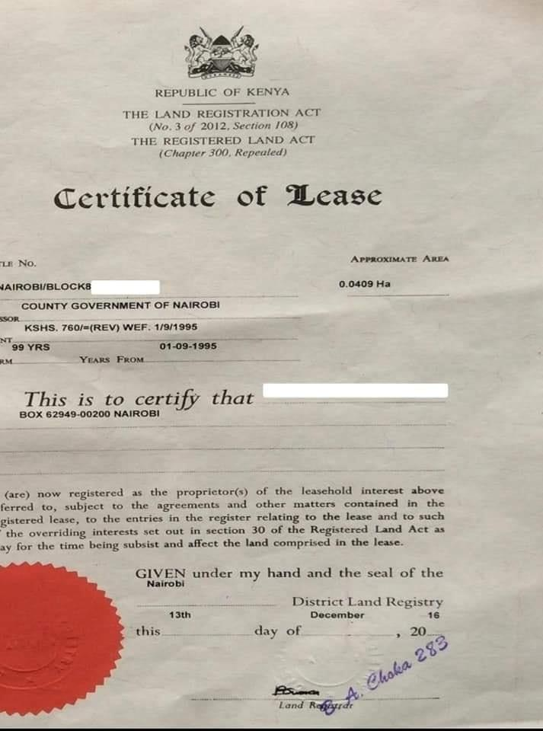

## (ii) Certified copy of the Head title

A title is adocument that shows legal ownership to a property or asset. A title can represent ownership of a real asset such as a car or an intangible property or assets such as a trademark*.*

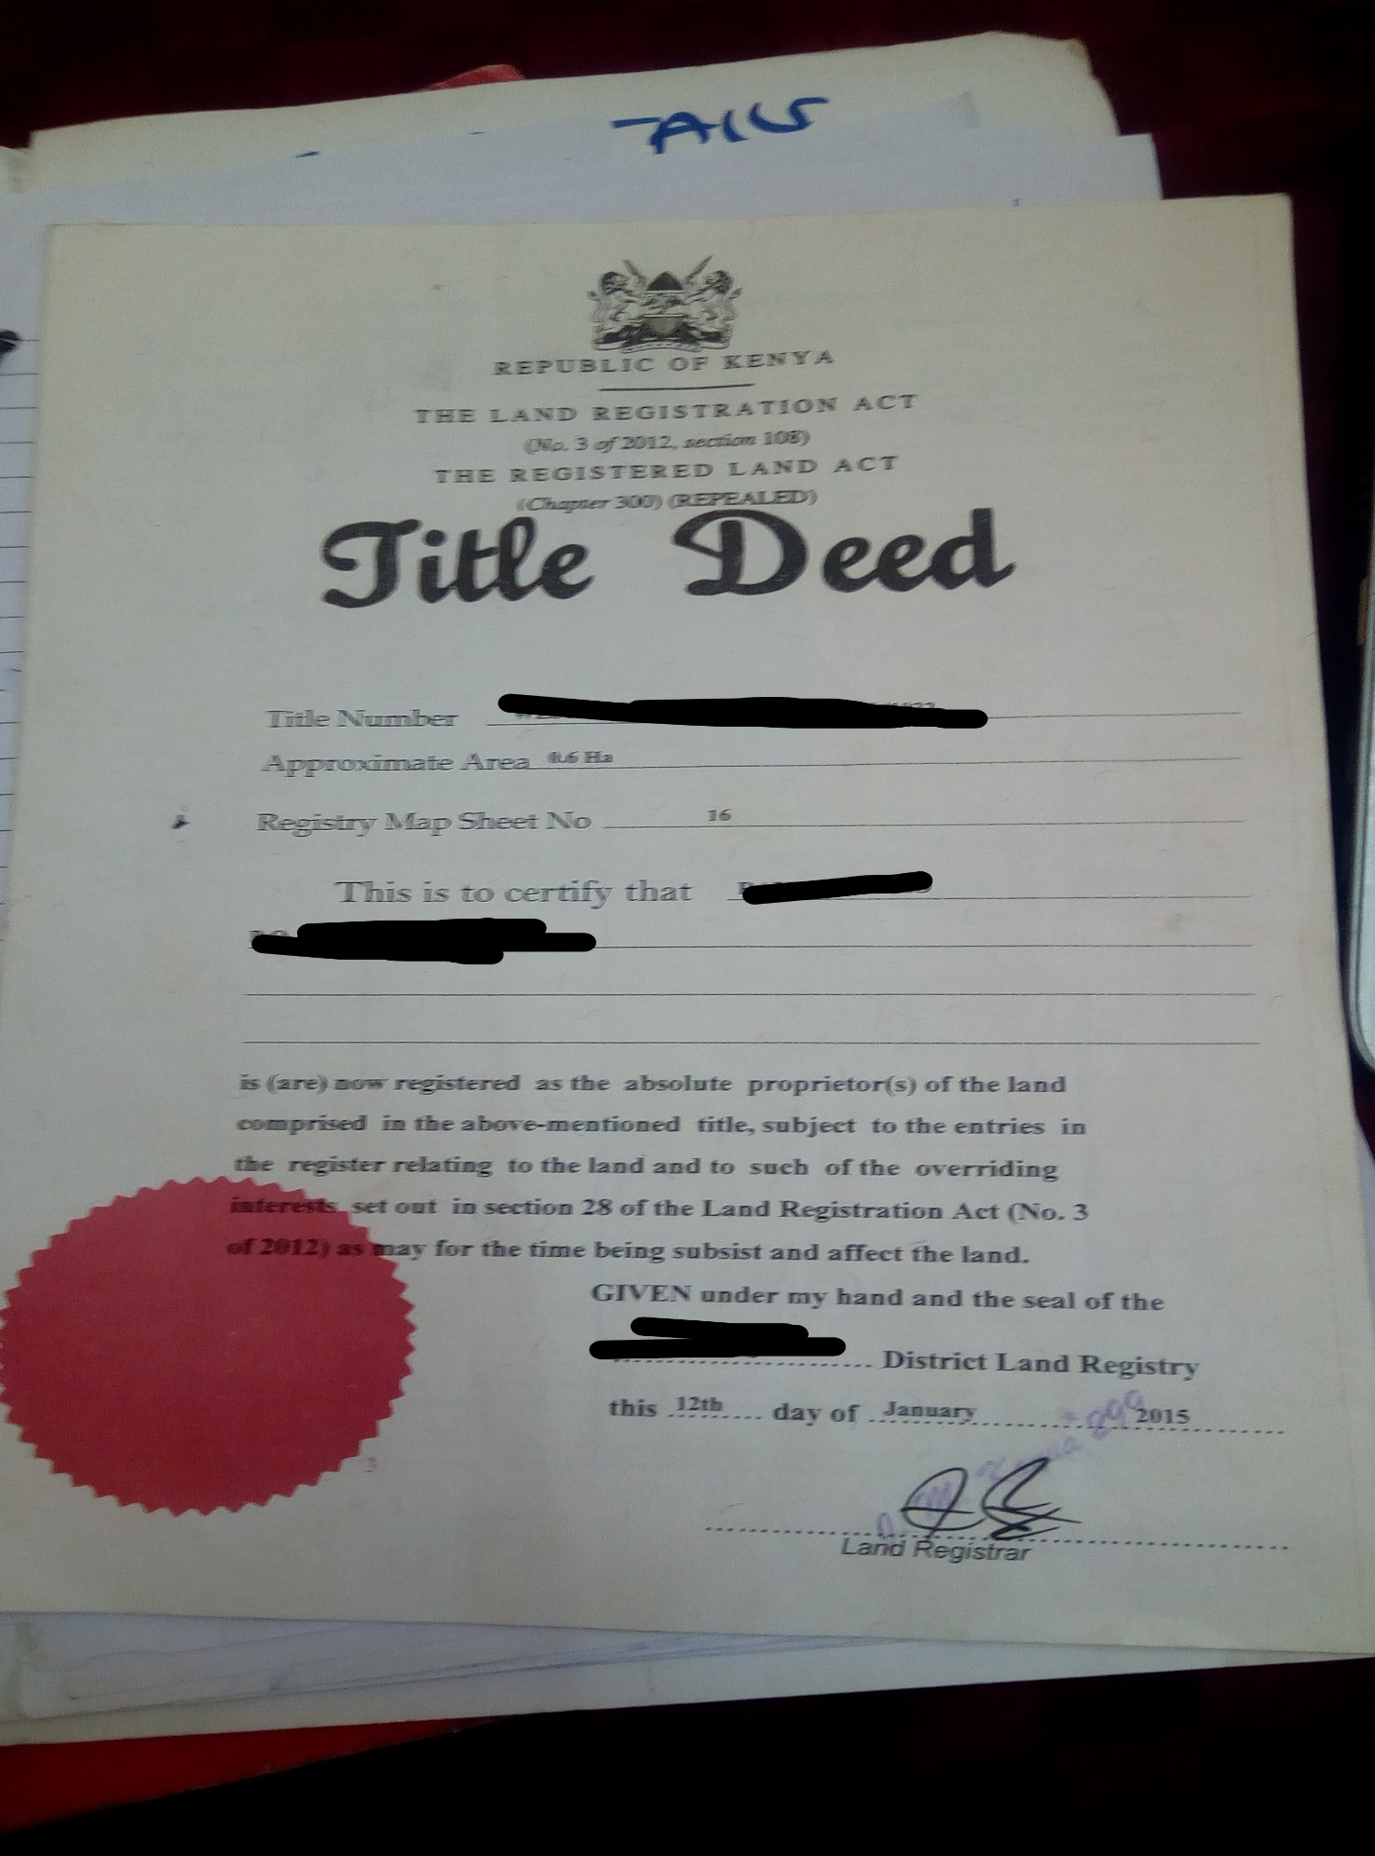

## (iii) Certified copies of Memorandum and articles of association of super height Point Properties Limited Duly-registered at the Attorney General`s Chambers.

Both documents form the constitution of the company. Articles of association define the purpose of a company and specifies the regulations for its operations. Memorandum of association defines relationship with shareholders, describes the companies details including the address, names of shareholders and the distribution of shares.

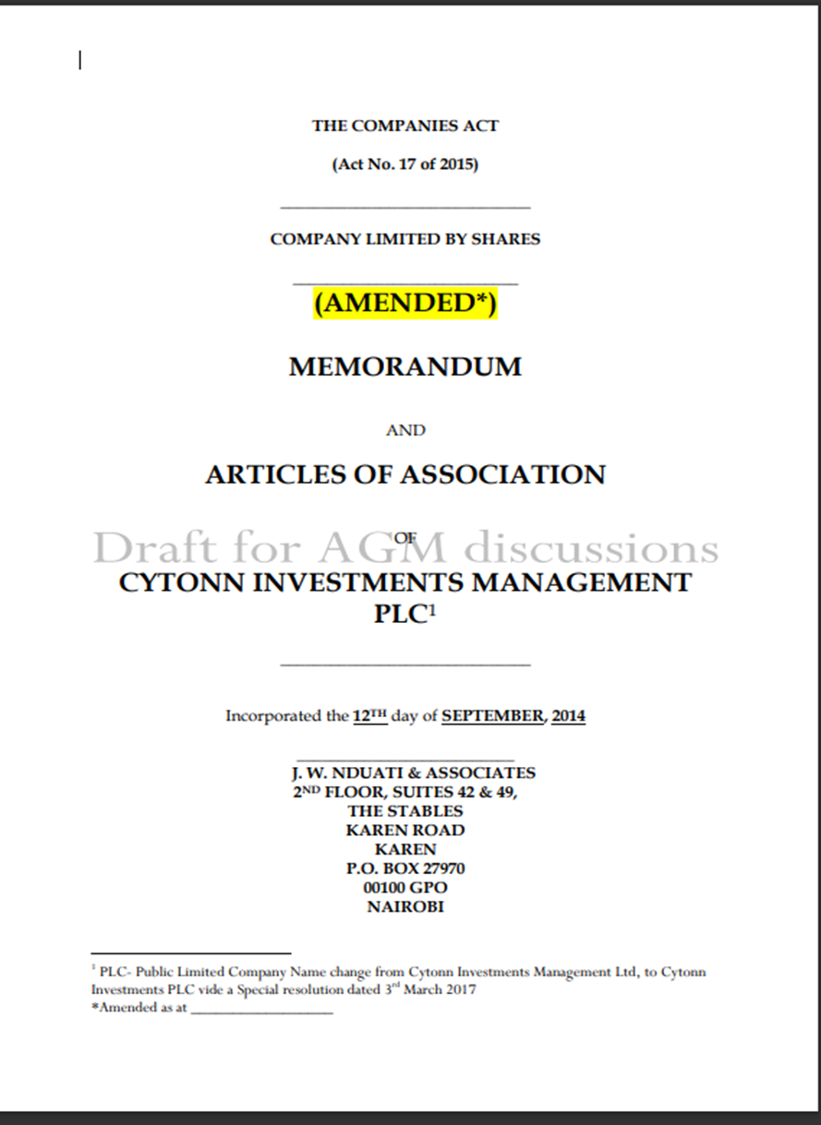

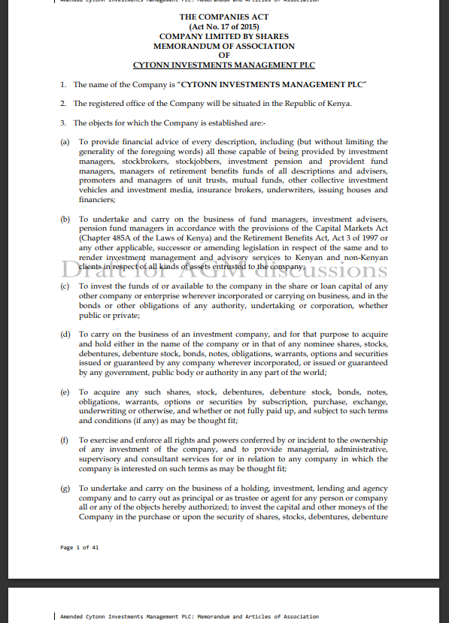

## (iv) The original KRA receipt showing payment of stamp duty.

KRA Acknowledgement Receipt is a document that is generated by the KRA iTax Portal that shows that an application, request, return, registration or amendment has been successfully submitted to [Kenya Revenue Authority](https://www.kra.go.ke/en/) (KRA) for processing and approval. The receipt serves as an acknowledgement that KRA has received the application or request that a taxpayer has submitted using KRA Web Portal. Since the Receipt is issued by KRA, it acknowledges or confirms the receipt of submitted application, process or task using KRA Web Portal.



## (v) Certified copy of National City County Occupation Certificate.

The Certificate of Occupancy in Kenya is a legal document usually issued by the local government agency or the housing/building department declaring a building’s compliance with relevant building codes and other laws, and indicating it to be in a condition suitable for human habitation. You may find a certificate of occupancy necessary when you need to sell a house or when you need to occupy it for everyday living and [when you have done your own construction.](https://nyongesasande.com/certifcate-of-good-manufacturing-practice-in-kenya/)

The purpose of obtaining a certificate of occupancy is to prove that, according to the law, the house or building is in liveable condition. Generally, such a certificate is necessary to be able to occupy the structure for everyday use, as well as to be able to sign a contract to sell the space and close on a mortgage for the space.

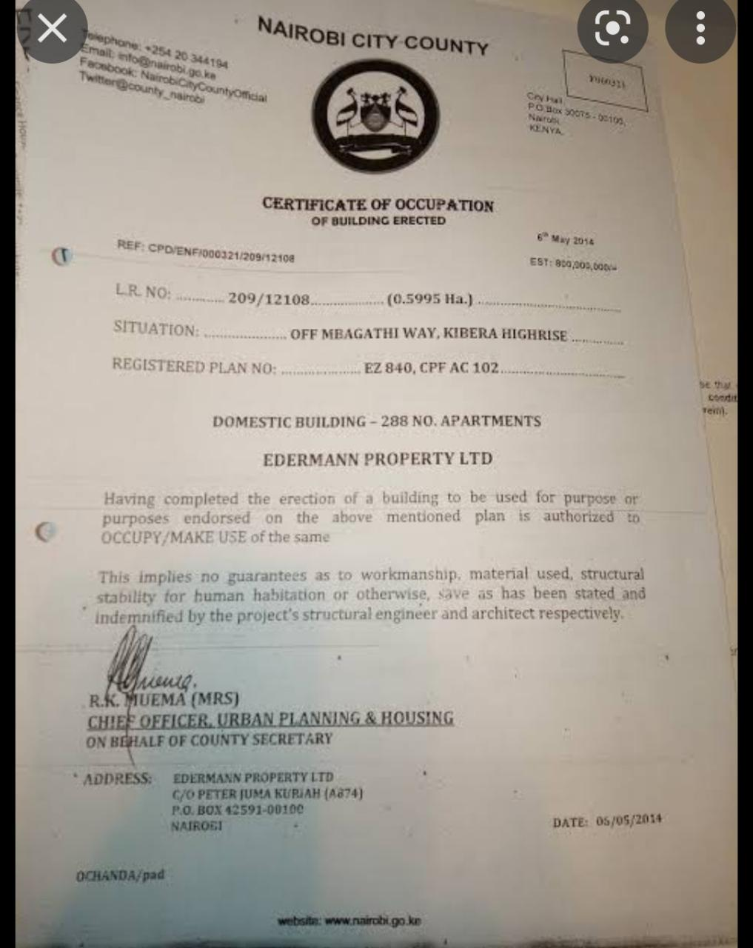

## (vi) Share certificate in respect of the purchaser`s share in the management company.

In a layman language, a share certificate is a document issued by the director of the company with the common seal to its member for subscribing the company’s shares. It explains the ownership of a number of shares a member purchased from the company.

As per **section 46 of the Companies Act, 2013** “a share certificate is a certificate issued under the common seal, if any, of the company or signed by two directors or by a director and the Company Secretary, wherever the company has appointed a Company Secretary, specifying the shares held by any person, shall be prima facie evidence of the title of the person to such shares”.

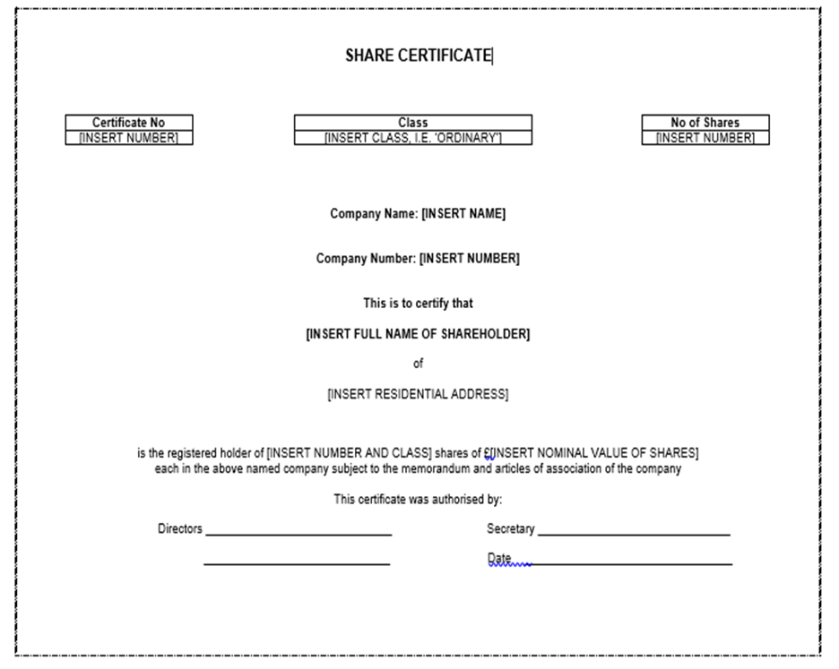

## (vii) Original receipt acknowledging payment

This document is to show record of payment of the lease premium instalment.

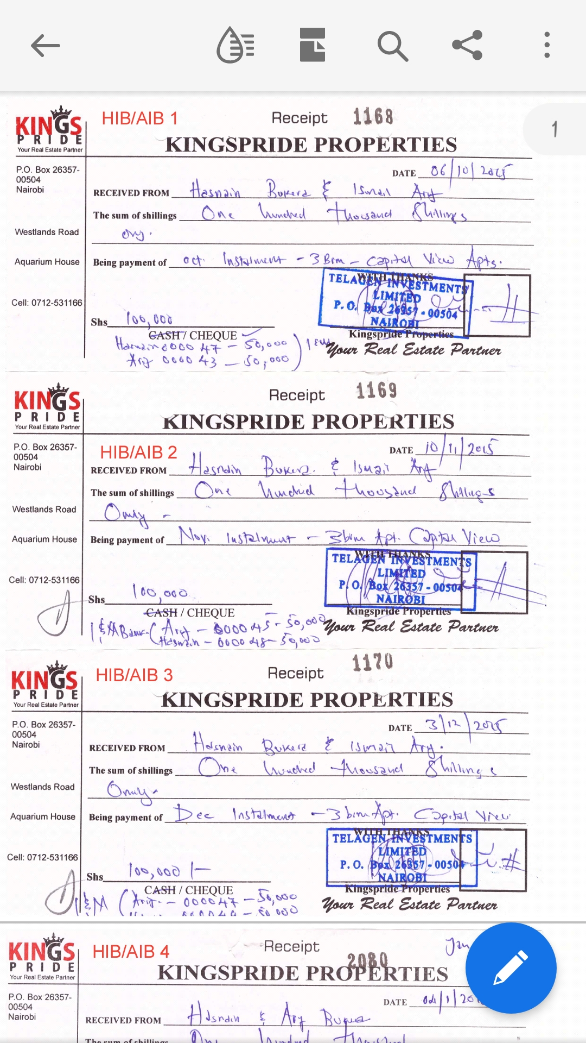

# **FIRM 5**

Sale agreement for a purchaser who is charging the property which is subject of the sale to finance payment of the balance of purchase price. The completion documents therefore are;

## Original title documents relating to the Property.

It proves the actual owner of the property either land or housing unit.

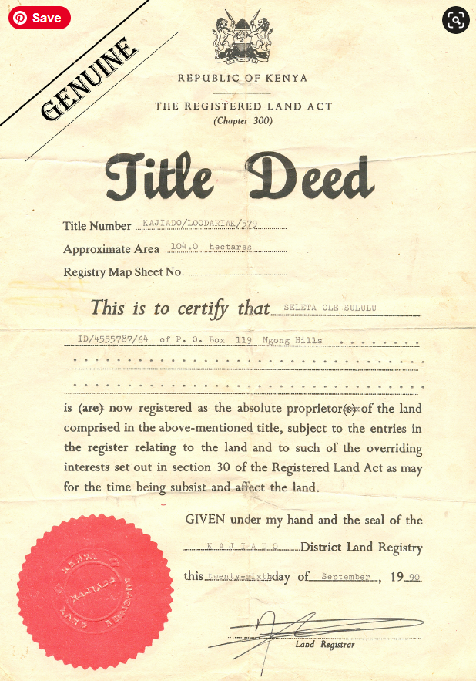

## Duly executed Transfer (in triplicate) in respect to properties in favour of the Purchaser.

This is to prove change of ownership of property from the seller to the buyer.

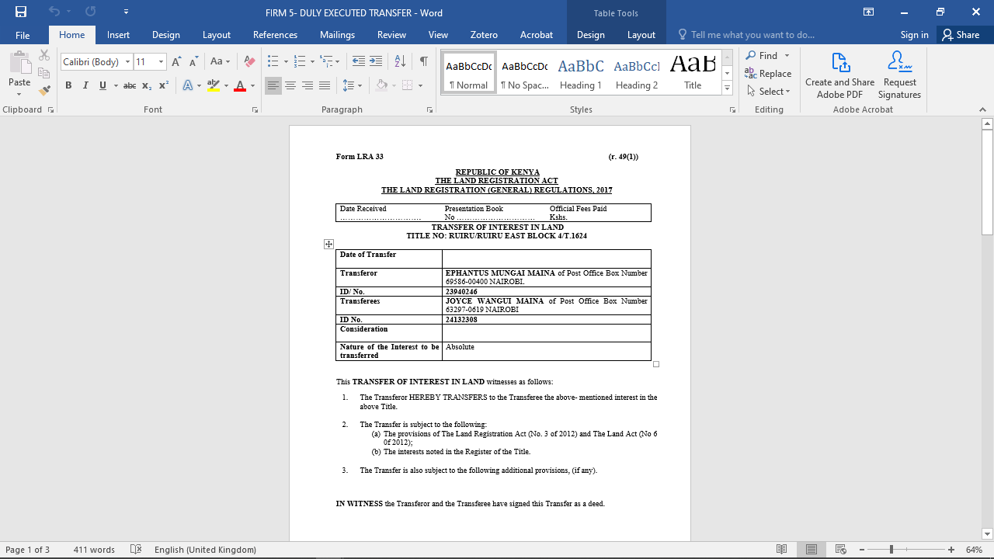

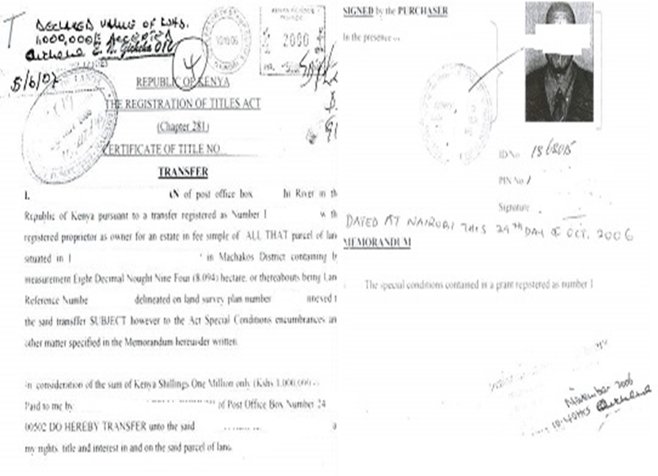

## Application for consent to transfer the Property and the attendant consent from the relevant Land Control Board.

The consent from the land control board is governed by the land control ACT cap 302. The purpose of this act is to control transactions in agricultural land. In **Nelson githinji et al vs. Munene Irangi COA** categorically stated any transaction, sale or transfer or other disposition or dealings in agricultural land situate in a land control area without a Land Board Consent is void. Having not been obtained within the required time i.e. 6 months, whole disposition was void as against S.6 LCA.

**REPUBLIC OF KENYA**

**THE LAND CONTROL ACT**

***(Cap 302)***

**APPLICATION FOR CONSENT OF LAND CONTROL BOARD**

To be submitted in TRIPLICATE in respect of each transaction and

Sent to or left at the appropriate office of the Commissioner of Lands

To: THE

LAND CONTROL BOARD

L.C.R

I HEREBY apply to the

Land Control Board for its consent to the transaction described below and give the following

information:-

1. (a) Present registered holder of interest (full name in BLOCK LETTERS):

**EPHANTUS MUNGAI MAINA**

(b) Nationality **KENYAN**

1. Address **N/A**

2. (a) Proposed purchaser, transferee, mortgagee, chargee, allotee etc. (full names in

BLOCK LETTERS) **JOYCE WANGUI MAINA**

1. If a liability company, names of directors, authorized and issued share capital and

Principal shareholders: if a co-operative society, names of chairman, secretary

And treasurer and total number of members-

c) Nationality  Certificate No.

1. Address
2. Nature of transaction (e.g sale, gift, lease, mortgage, charge etc: if sale or allotment of

shares, name of company, number and particulars of shares to be transferred)

**TRANSFER**

* 1. Term (i.e. the length of time for which the land affected is to be transferred or leased: if sale or allotment of shares, authorized share capital of the company and numbers of shares issued at date of application)
  2. Description of Land-

L.R. or Parcel No. **RUIRU/RUIRU EAST BLOCK 4/T.1624**

Area **0.0800HA**

Locality

County Council **THIKA**

6. (a) Purchase price, if sale or option .. .. .. Sh.**700,000/00**

Rent .. .. .. .. .. .. Sh. **……………**

Estimated value of the land (if a gift) .. .. Sh.

Amount of loan (if a mortgage or charge) .. .. Sh

Rate of interest (if mortgage or charge) .. .. ……………….%

Any other information affecting the amount of the consideration, particularly

regarding the description and area of crops with estimated yields and value

thereof included in the purchase price

1. Full description and approximate value of improvements on land included in the

Consideration

1. Any other consideration passing between the parties

7. If a transfer or lease of the land-

Proposed development programme of purchaser, including funds available therefore

with approximate date

Does the purchaser/lesee intend to reside on the land?

8. (a) Other agricultural land registered in the name of or held under contract for sale

by the proposed purchaser, transferee, lessee or allottee, or any member (s) of his

immediate family, or any company in which he has an interest (state the nature of any

interest in such company)-

L.R or Parcel Nos.Area

Owner

Nature of interest

Whether contiguous to land being purchased

1. Particular of agricultural land held and disposed of by purchaser or lessee in the last three years-

L.R. or Parcel Nos.  DistrictArea

L.R. or Parcel Nos.  District  Area

9. Farming experience of transferee

We hereby declare that the above information is true to the best of our knowledge and

belief

Signature of purchaser, lessee, Signature of owner, lessor,

Mortgagee, chargee, or authorized Mortgagor, chargor or authorized Agent

or agents, etc. agent or agents, etc.

Date Date

If spaces allowed under any particular item are sufficient for the information, a separate sheet with item numbers and duly signed by all parties or their authorized agent or agents be attached.

## Three (3) colored passport size photographs of the Vendors as well as copies of the Vendors’ P.I.N Certificate and National Identity Card.

Passport size photos and national identification card are availed for identification purposes.

What is the KRA pin certificate? A KRA PIN is a Personal Identification Number used while doing business with Kenya Revenue Authority, other Government agencies and service providers. The use of the pin in correlation with this sale agreement is for; Registration of title, stamping of instruments by the Commissioner of Lands, and payment of Land Rent.

## The Spousal Consent or Affidavit of singlehood (whichever is applicable).

Under S. 93 (3) of the LRA requires the consent of a spouse, where the spouse seeks to charge or transfer matrimonial land or a dwelling house which that other spouse holds in his or her name individually. The consent is usually given in a form of an affidavit. For any transaction that relates to matrimonial property, it is important to obtain the consent of the spouse to the registered owner. This bars the spouse from later on trying to challenge the transaction claiming they were not aware.



## Receipt of payment of Capital Gains Tax (if any) Rates and Rents.

It is the tax charged on gain accrued from transfer of property. Eg building, land or shares.

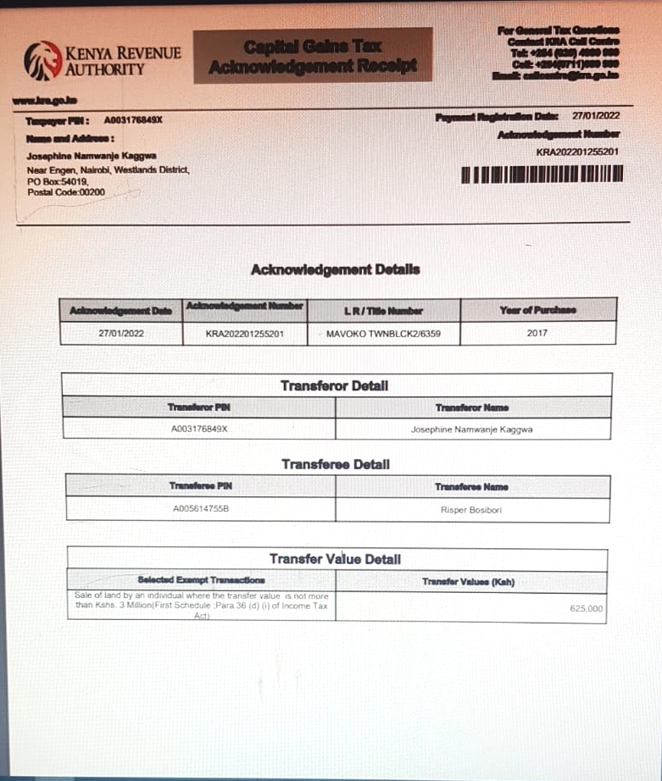

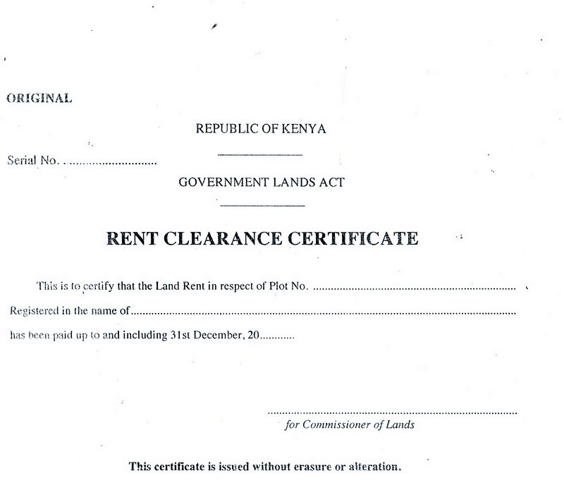

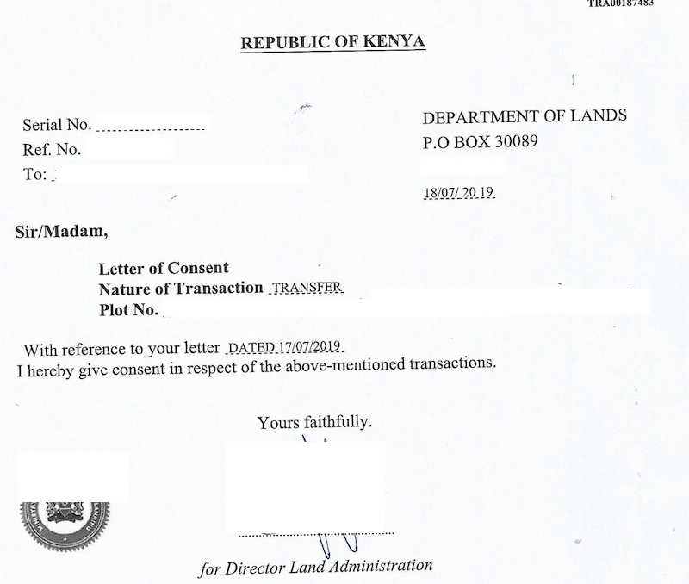

1. Tom Ojienda, ‘*Principle of Conveyancing in Kenya: A Practical Approach* Law Kenya (2007)
2. The Law Society of Kenya Conditions of Sale and Agreement for Sale Layout, 2015
3. Elizabeth Cooke, *Land Law* (2012)